**PRATIK GUPTA**

**GIT BRANCHING – HTML ASSIGNMENTS**

**SECTION 1 – (21-38)**

**Objective: Commit HTML, CSS & JavaScript assignments into GIT.**

**SECTION-1 (HTML assignments) - Steps to follow:**

**21. First take a backup of your assignments & projects. This is required because due to**

**incorrect GIT operation you may lose your files.**

**22. Create an empty directory ‘Assignments’ & cd to ‘Assignments’.**

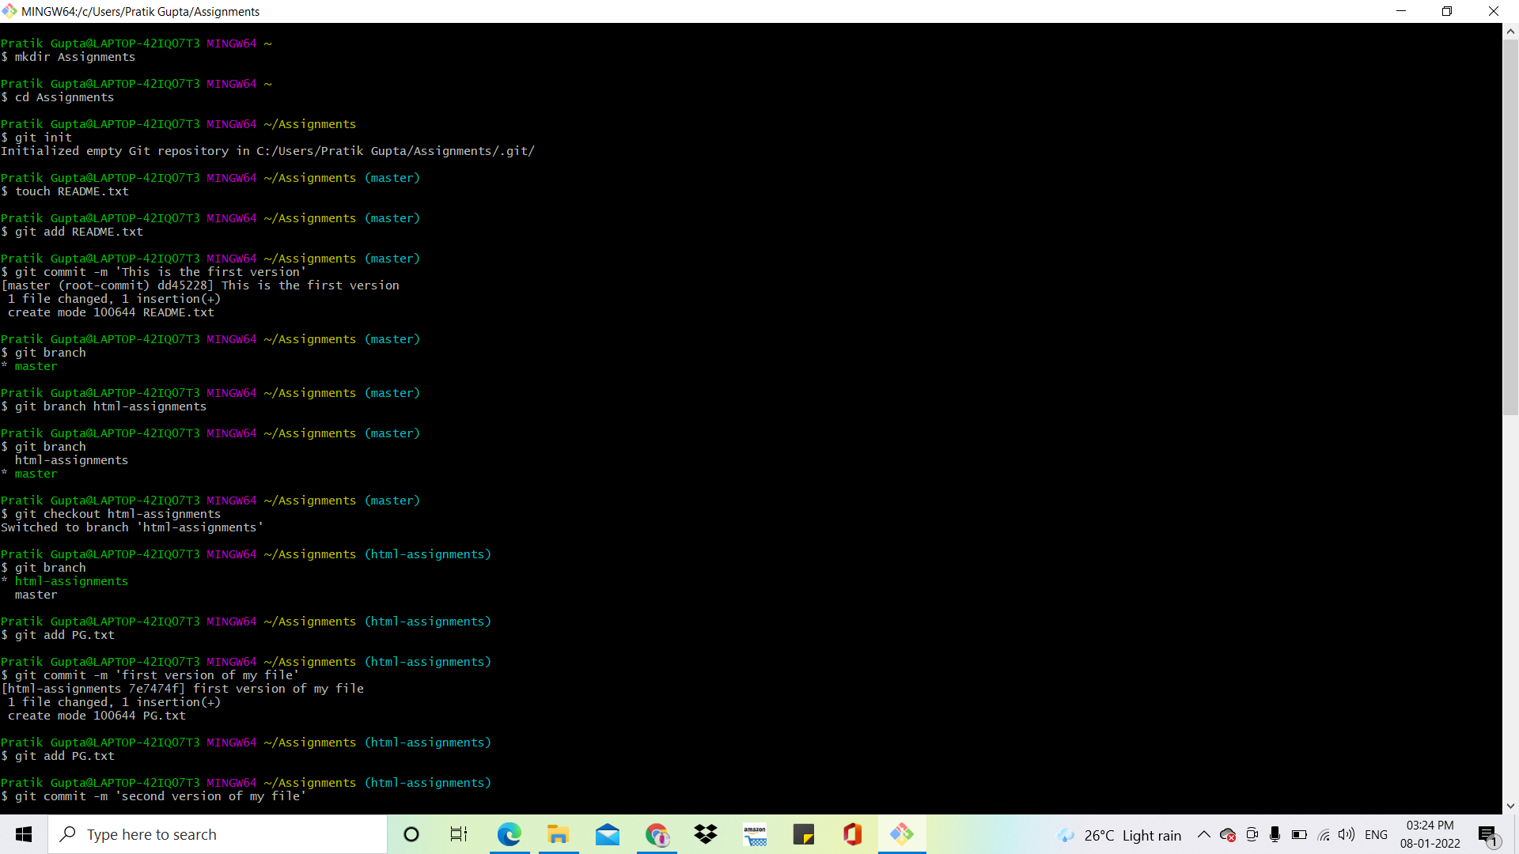

**23. Create a file README.txt inside ‘Assignments’ & write few lines about the contents of ‘Assignments’ folder.**

**24. Commit README.txt file.**



**25. Now create a new branch ‘html-assignments’.**



**26. Switch to ‘html-assignments’ branch.**



**27. Copy all HTML assignments inside ‘Assignments’ folder.**

**28. Commit HTML assignments into ‘html-assignments’ branch.**



**29. Make minor changes into few files belonging to ‘html-assignments’ branch.**

**30. Commit those changed files.**

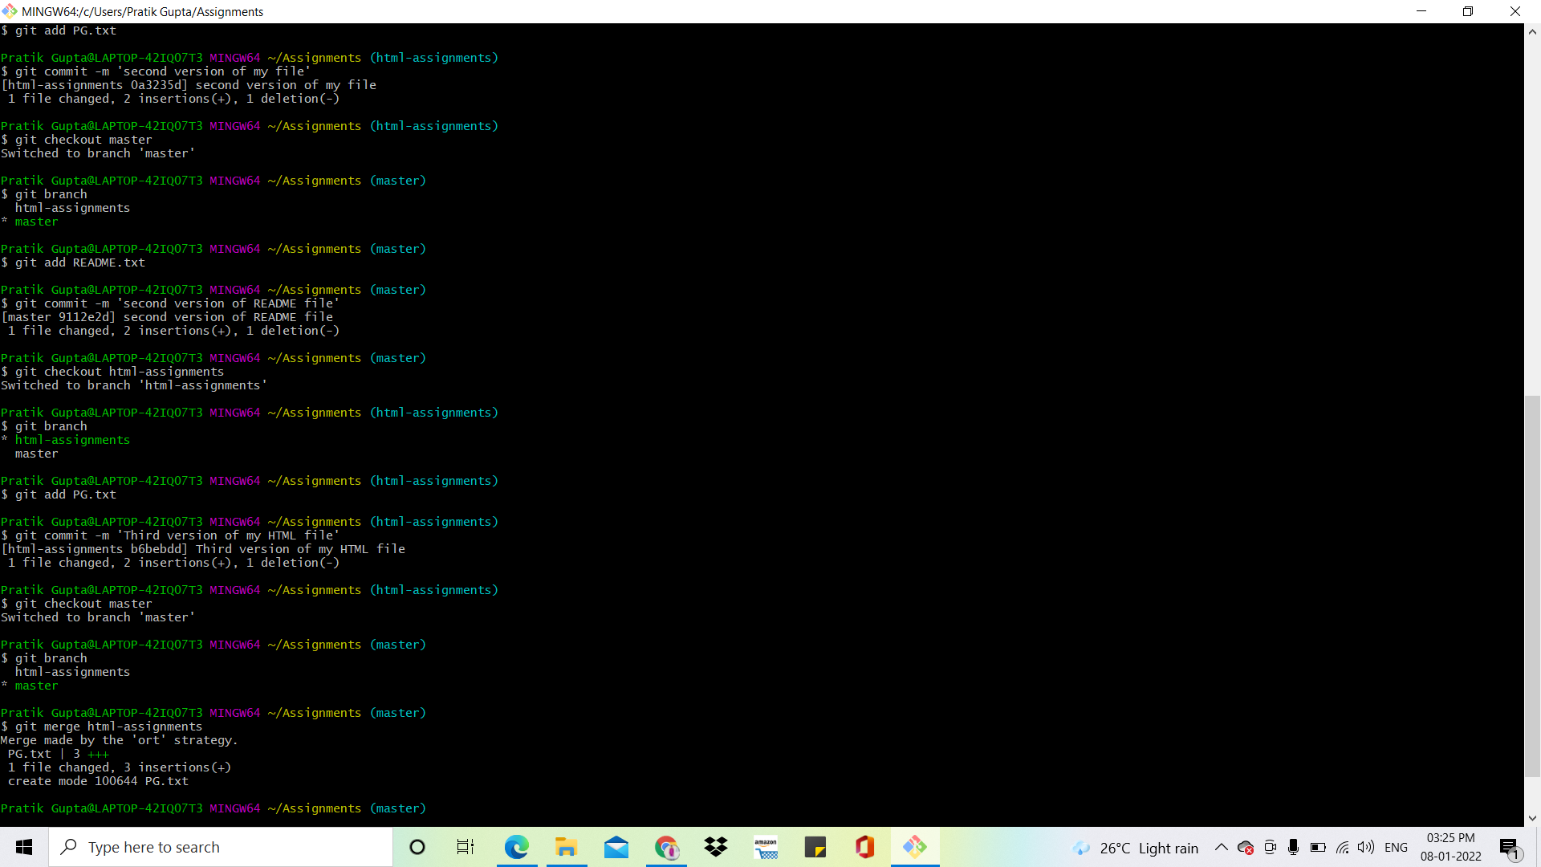



**31. Switch to master branch.**



**32. Make minor changes into README.txt file & commit those changes into master.**



**33. Again switch to ‘html-assignments’ branch.**



**34. Make minor changes into few files belonging to ‘html-assignments’ branch.**

**35. Commit those changes.**



**36. Switch to master.**



**37. Merge ‘html-assignments’ branch into master. Confirm all html assignments are shown in master.**



**38. Finally delete the ‘html-assignments’ branch.**

